Newsletter 2019
Dear Friends of Panorama Rock, just a short update on the past year from our side.
This year was all is about survival …… Survival at core level.

It felt like everything turned into dust ….
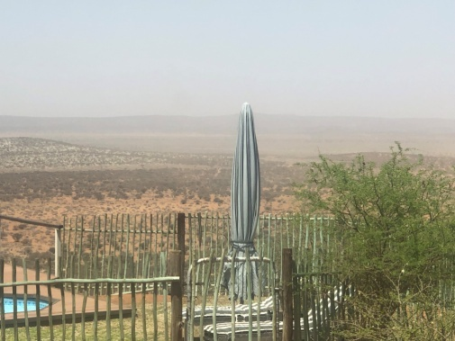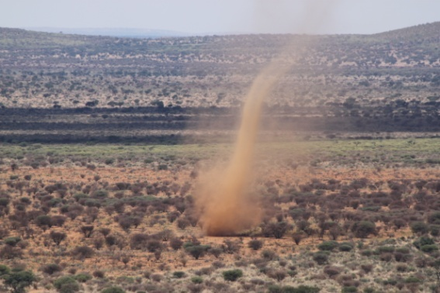
We braved the economy, the weather, the drought and our tears.
Since the 11 May 2019, we at Panorama Rock had to start fighting for ourselves, as Gunnar, who did most of all our “fighting”, passed away unexpectedly during a cycling event, and left the year even more desolate.
We will remember him as a personality who could connect with almost every living being (children, more senior citizens and animals). Gunnar always strived to make the dreams of many people come true, and tried to make time for everyone and everything. We will remember him as someone who loved life and enjoyed everything that “touched” his senses, passionately. Everybody who knew Gunnar will testify how much he loved life... especially culinary specialties , exploring new ideas and places and taking photos, which he thoroughly enjoyed as well.

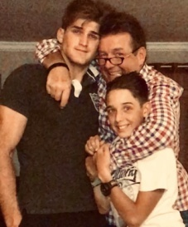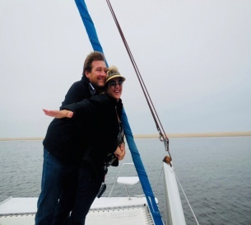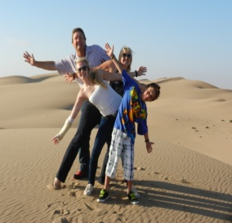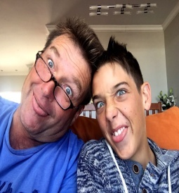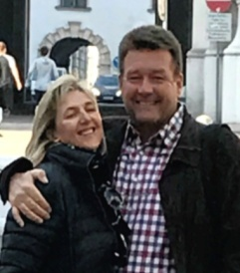
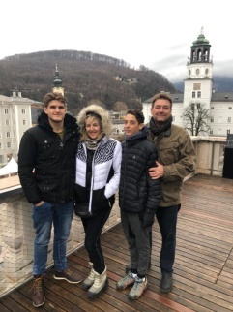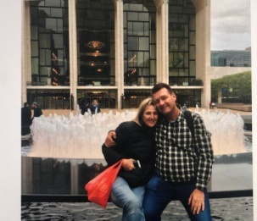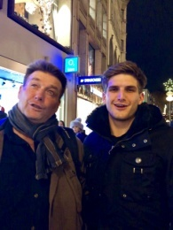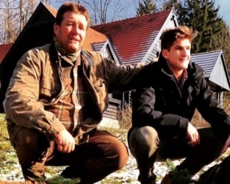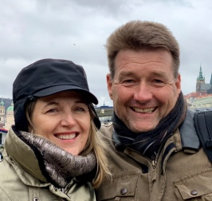
At Panorama Rock Lodge, not only his entrepreneurship will be missed, but also his knowledge, immense presence and jokes.
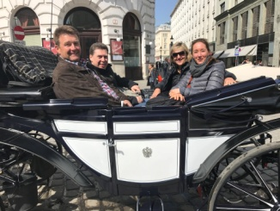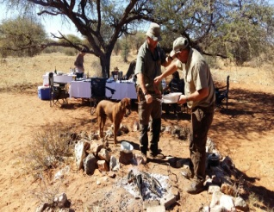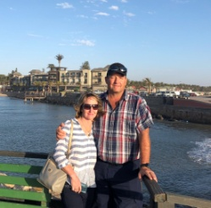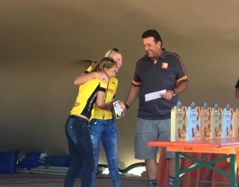
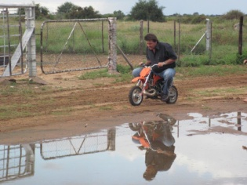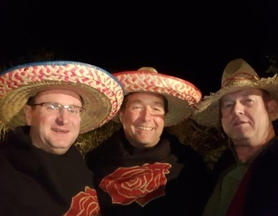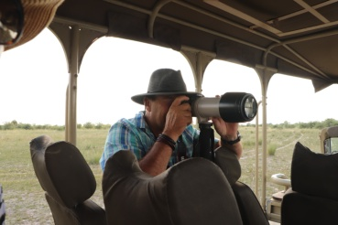
Gunnar leaves a hole in the lives of friends, family and colleagues, but most of all in the hearts of Marinda, Bergran , and Sören. Last but not least, also our dogs: Google, Sancho and Sonic.
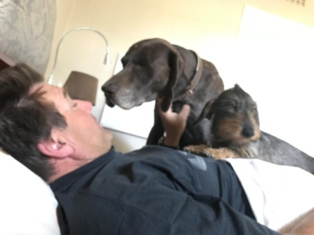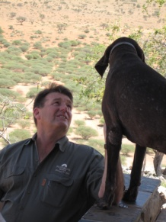
A Huge thank you to Gert and Sandri Olivier for their unbelievable inputs since, and for all their sacrifices the past year. They are the backbone of Panorama Rock, and became such close family over the past few years.
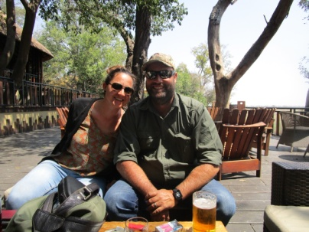
As said, it was not a normal year Gert and Sandri lost their hunting partner and friend, Baron too. We are all missing him dearly.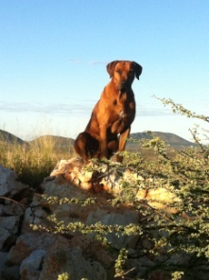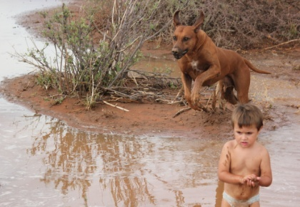
On the farm not all animals survived the drought, but lots were saved as Gert made “Boskos” and we bought a lot of fodder.
The positive thing coming from years like these, is that we are going to have a really strong gene pool to breed from. We as neighbors also learned, renewed, that one goes much further if you stick together in these times.
“Droogte”(meaning dry), an Eland calf was saved and became part of the Olivier family. She believes she is a dog and Sandri and Gert has put her in the camp with the sables since December, together with the tortoises.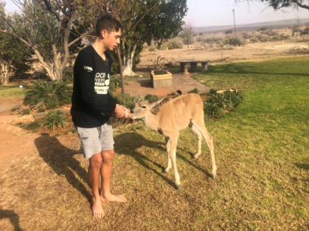

About our “forced” new beginning:
Dear guests we want you to know that nothing will change at Panorama Rock Game Ranch, which will affect you. You will still be treated with the usual hospitality by our Team.
We will strive to build on the legacy that Gunnar and Marinda laid the foundation of, and Gert and Sandri will continue to build on.
Both the Jensen and Olivier families are doing well. We are all healthy, fit and ready for the changes, chances and challenges in 2020.
Soeren made us very proud as he graduated in 2019 and his career in the adult world is about to start.
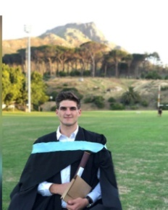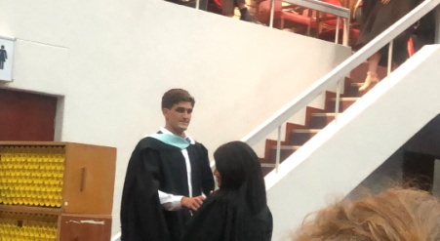
Bergran is going to grade 10 and obtained many prices for his cycling this year. He got the Costa Seibeb trophy for best upcoming cyclist and was Namibian Champion for 2019. His team was also the winners of the mixed team category of the Dessert Dash, a very challenging night-race in Namibia. His next goal is to attend the world championships in Germany 2020.
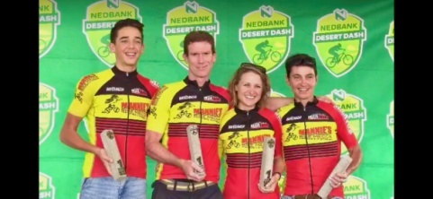
F.C Olivier: He is doing very well in school and partakes in rugby and cricket at school.
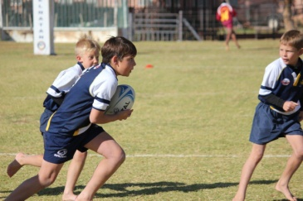
Charl Olivier has another year before going to school.
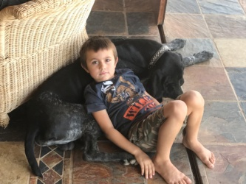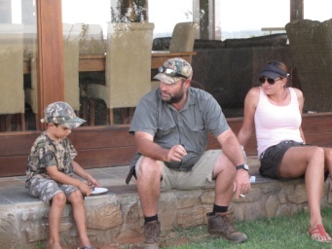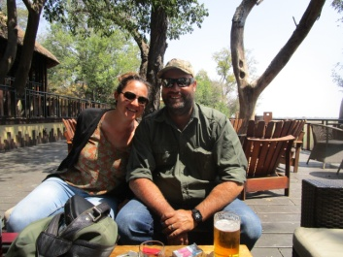

We also had an African themed, 50th birthday of Silke Hartman at Panorama Rock.
Our Team wishes you a happy Christmas and a prosperous new year! 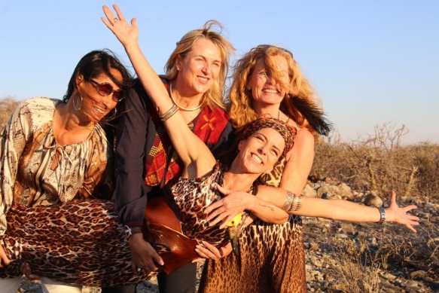
The great news is that our wheels of fortune are turning, as we had some rain on the farm already.
We are hopeful that next year will be green again and that we, together with our animals, will have a chance to a fresh start in 2020.
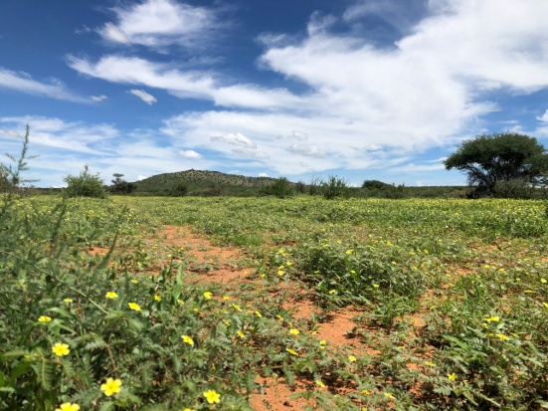
Our team is looking forward to welcome you at Panorama Rock soon.
… On 2020!!! May it be the year of fresh starts and dreams coming true….

