PANORAMA ROCK GAME RANCH
Newsletter 2020

To put a humorous angle to 2020,
…. (The year the world stood still) ….
Compare it to an Indiana Jones Movie, which describes it pretty accurately!
Wherever you touched was some dragon to threaten your existence. The moment you thought you can revive, was the moment 2020 just prepared for the next level of the Covid-game. The only difference is that Indiana Jones knew when he gets the treasure it’s the end, a luxury which Covid 19 does not give us.
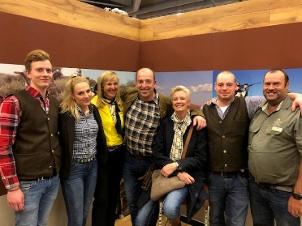
The year started off very well. Marinda and Gert had a very successful hunting show in Germany.
We put up new signage at the lodge, Sandri designed a lovely water wise garden, we welcomed the first few groups of guests, and then lockdown started.
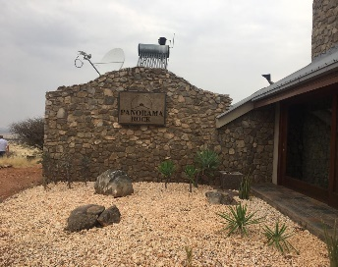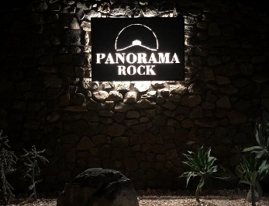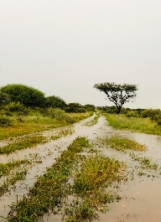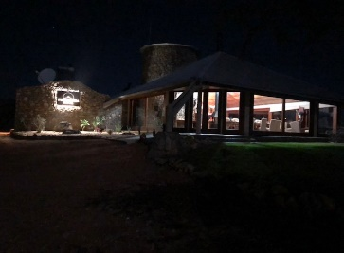
Nevertheless, were we very blessed at the same time
Besides discovering the threshold of our human nerves, we were extremely grateful for a good rainy season, and for the lessons life taught us this year such as:
- The value- and revival of connections with Family, Friends and Neighbors
- Our local regular hunters and guests supporting us
- To think out of the box
- To become comfortable not knowing and to be patient
- You can trade without money, every farmer produces something
- Dealing with change generally and globally
- To respect money and not to refer to “just a thousand dollar”
- Learned again that time lost is time gone forever
- To go on our knees and thank God that Covid did not happen during the drought, amongst other things.

As the saying goes, if one door closes other opens:
Both families assisted during lockdown to cut grass that we could sell bales. Bergran and Sören assisted Gert. A friend got stuck in Namibia and applied his skills to keep our machinery running, which was a blessing on its own.
Sandri’s house turned into a school and homeschooling started for FC and the farm children.
2020, also gave birth to “Michelle se Kombuis”. This is Sandri’s organic frozen food range, produced by Panorama Rock’s team and sold in Nambia. Panorama Rock is proud to be part of the twin sister’s venture. This range gave birth to our own organic grown vegetable garden, Gert’s pride! Last but not least, we are now supplying our own milk and cream.
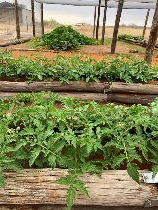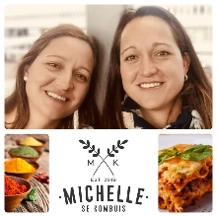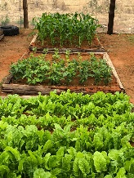
Lovely happenings in Namibia that our guests missed out on this year, was definitely our *grass covered savannas with extraordinary birdlife.
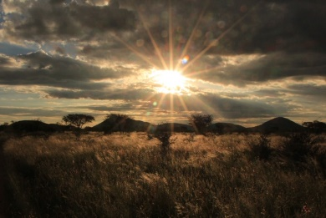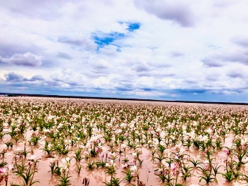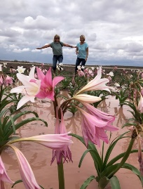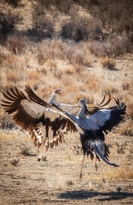
*Also, seeing the new game that we purchased after the drought. *The hundreds of hectares of pink flowers which covered the water pans in Maltahöhe was absolutely spectacular. *Etosha Pans was flooded and was an experience on its own.
At the lodge we started new ventures such as entertaining cycling- and horse riding groups as well as themed dinners and birthday parties, which was a different kind of fun.
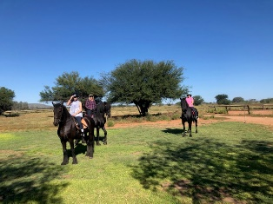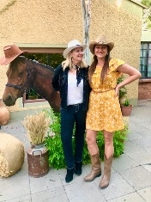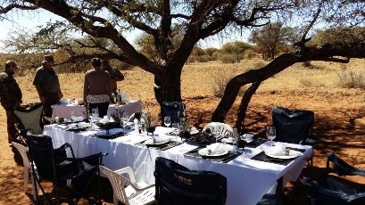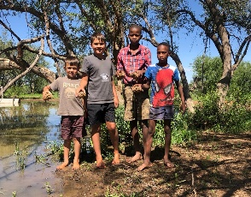
Jensen and Olivier Families
Apart from getting the late Estate sorted out, Marinda’s home garden took new shape. The kids assisted and also build the home gym.
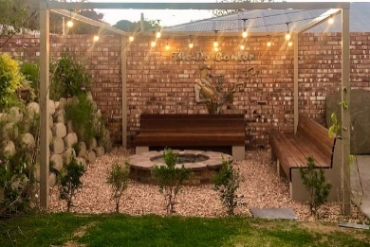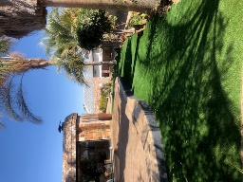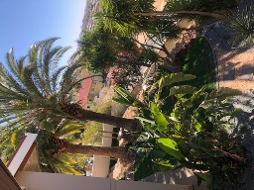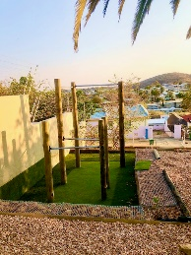
She was also very happy to have both children at home, although, it was not the way that Sören anticipated staring his career path, after he finished studying in 2019. He then worked on the farm and in Windhoek whilst waiting to see what is left of the world after Covid, as, he is still aiming to go overseas as soon as possible.
Bergran’s cycling year started off with a bang qualifying to go to African - and World Champs, to then only learn that life happens, and not everything can go according to plan. You have to adapt…. A valuable lesson for his young future. He obtained his learner drivers license and took well to the discipline required doing homeschooling.
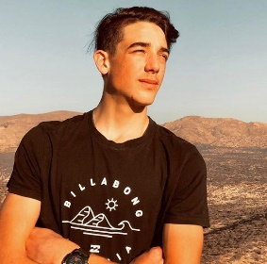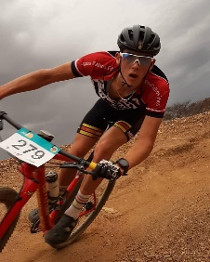
Sandri and Gert missed their South African family a lot, but all the ventures that they were busy with on the farm kept their minds from it.
FC got an award for his awesome mathematic marks, and Charl will be going to school next year.
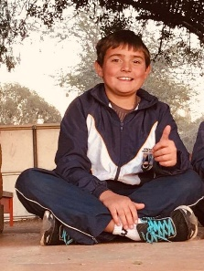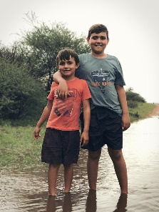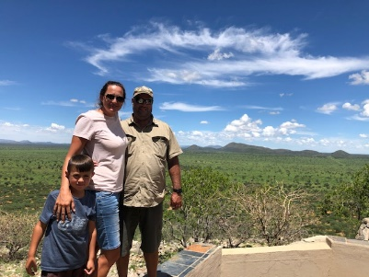
Our four legged Team mates are well. Google does not hear, but is fit. Sancho had a disagreement with a baboon and was almost ripped apart and recovered miraculously.
Covid, the Olivier’s ridgeback is the new addition to the hunting team and well looked after by Levi.
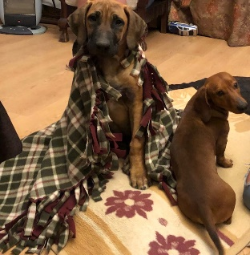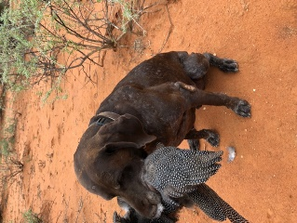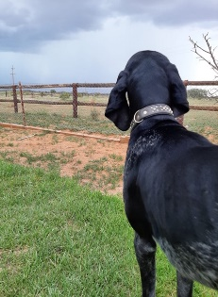
On the political front we welcomed the news that Swapo do not have a 65% majority anymore, and that we now have democratically elected constituencies who will now benefit the wellbeing of all Namibians.

On that note …
We missed our tourists in Namibia and
WISH YOU ALL A MERRY CHRISTMAS AND A PROSPEROUS 2021. Just remember to read the terms and conditions before you sign up for 2021, to avoid any surprises!
We at Panorama Rock Game Ranch are looking forward to welcome you all again, in the “new normal”, and would like to remind you, that at our lodge, we do not mix groups and you will not be exposed to strange viruses.
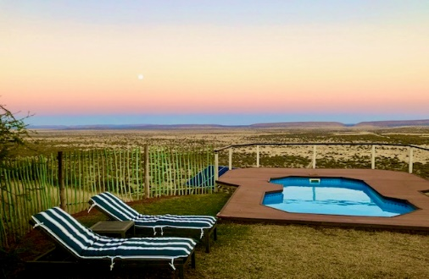

REMEMBER: INVESTMENT IN TRAVELING, IS AN INVESTMENT IN YOURSELF.
