An Eagle’s view on our 2021 journey

The Panorama Rock Team embarked on Flight-2021 full of energy and hope, flying towards the uncertainty of new challenges and opportunities to be discovered the year ahead.
Early into our flight we saw good rains, delightful green plains of grass, happy animals, a vegetable garden, any vegetarian will die for,( … with even some truffles!) To top it all, a nearly fully booked lodge.

All game species affected during the drought are busy recovering well and everywhere is offspring to be seen. Our Cattle are calving s well and brings sunshine to our days.
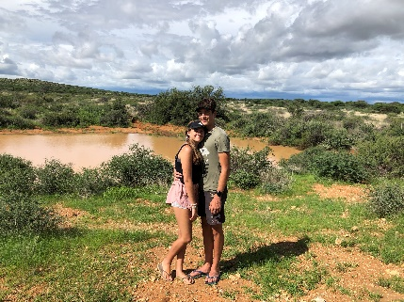
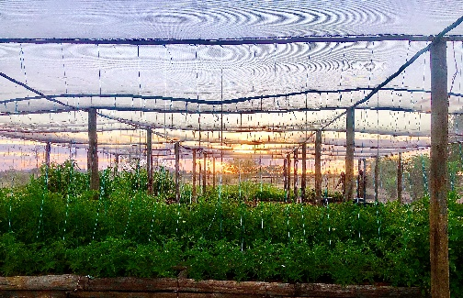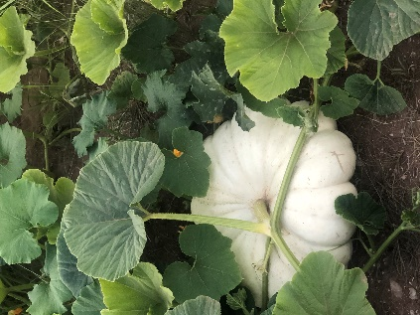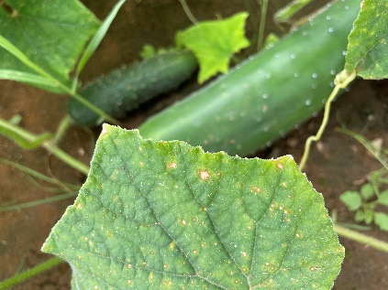

On National level, we looked down, on a first time ever, completely full Neckerthal dam but empty state coffers.
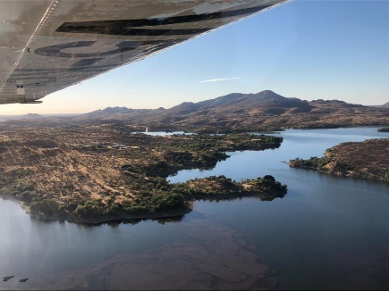

Back at the Ranch, we celebrated. A Raindance party to show our gratitude, not only for the good rains, but also to thank our neighbours for their unbelievable support. It was great fun to observe the creativity everybody dressed up with as Cowboys and Indians!
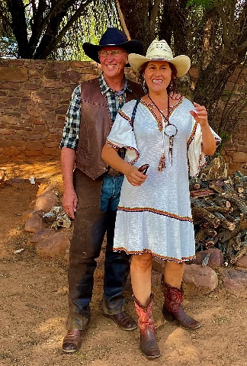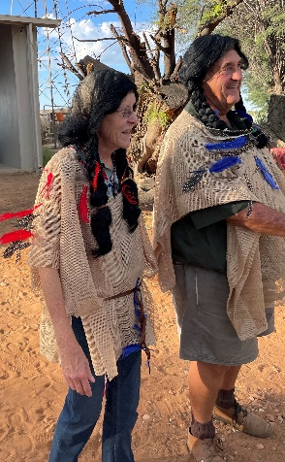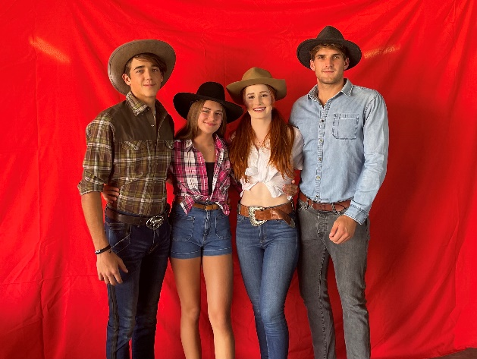
In April we saw the arrival of two Friesians, Bolero and Patrian. Marinda and Gert fetched them in Hentiesbay, and they are now welcome assets to our activity list. Our Clay Pidgeon range was the centre of attraction during Easter.
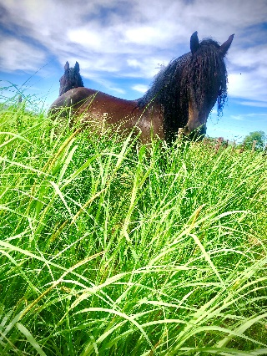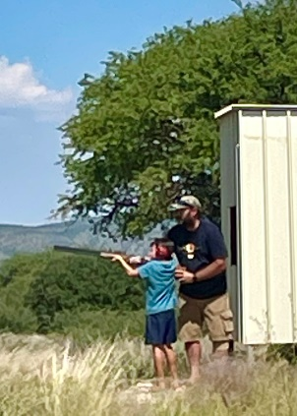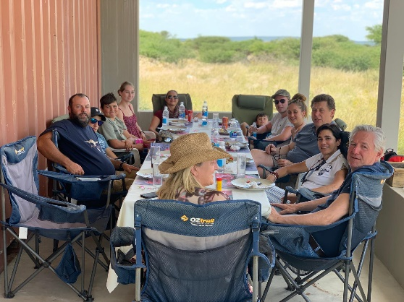

June saw another crash landing which lastet till the beginning of September. Our International market’s Covid regulations, caused many cancellations. We were very thankful for every Namibian and South African visit during these times.
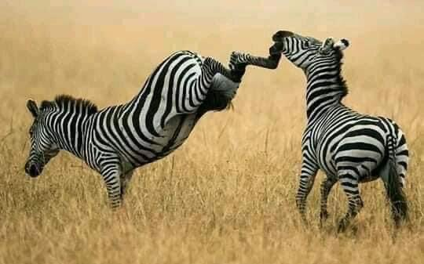

A few dear friends and acquaintances disembarked the flight during 2021 as result of Covid. Many of them left huge gaps in families and in the skill-pool of our developing Namibian economy. They will be dearly missed. Bless their souls. This virus is an undeniable challenge worldwide.

During our quiet time, we had the opportunity to advance our butchery personnel, with expert training from Germany. Thanks to Karl Schmid.
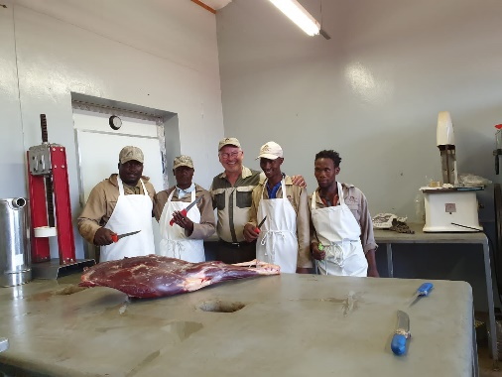

Our Panorama Rock – Team’s commitment to our guest’s dreams, took us on journeys and to places not only unexpected, but outrageously beautiful. We regard it a privilege to assist guests to tick off their bucket lists.
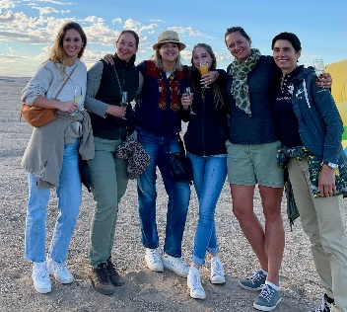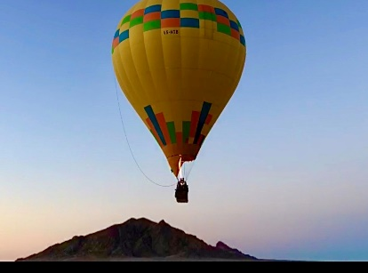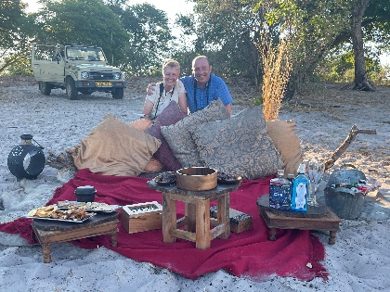
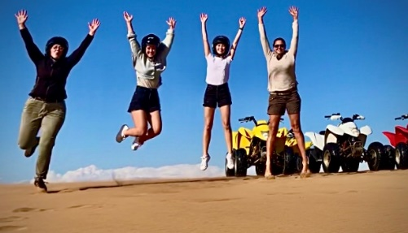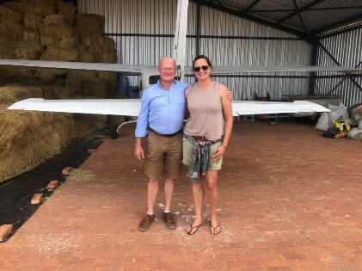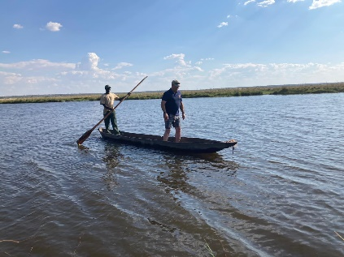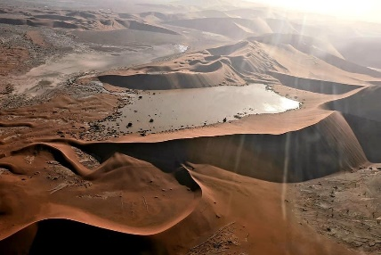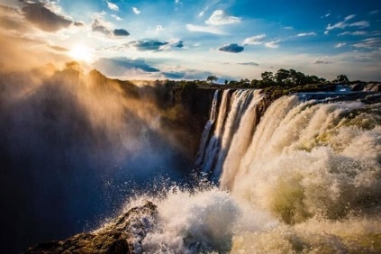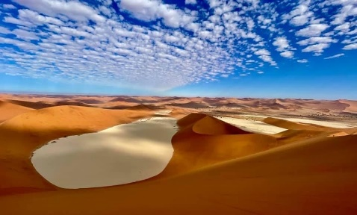

Experiences like buffalo hunts, scenic flights over Namibia, balloon safaris, bundu bashing the Caprivi to name but a few.
Sounds like fun? Well, as the saying goes, if you love what you do, you will never work a day in your life!!
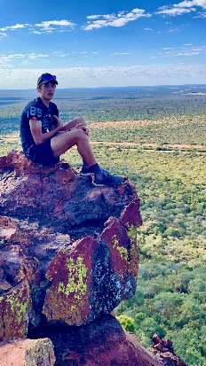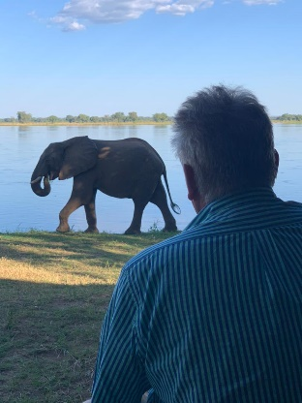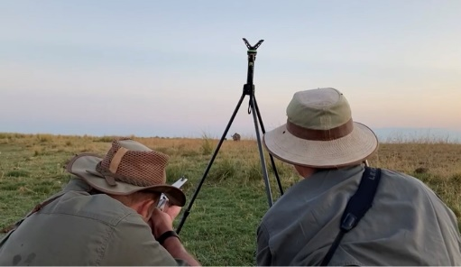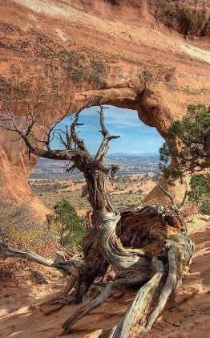

IMPORTANT INFORMATION: OUR ENTIRE PANORAMA ROCK TEAM IS NOW FULLY VACCINATED
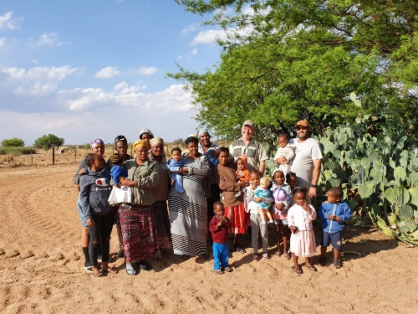

Oliviers
We saw the Twins excel with Michelle se kombuis. The business got the Networker of the year award, and 2nd place for Entrepreneurship on Afriforum. An achievement to be proud of.
Charl and FC‘s school year was a bit rocky, and mostly online, but, they were flying through their grades! Charl with seven A’s and FC also did very well with an A in mathematics. They will be in grade two and six respectively next year.
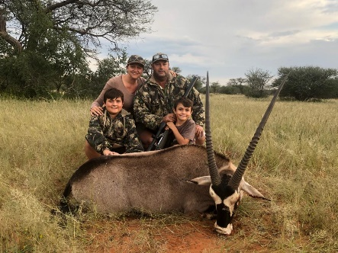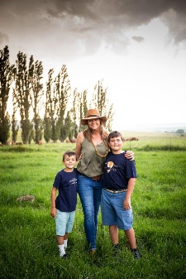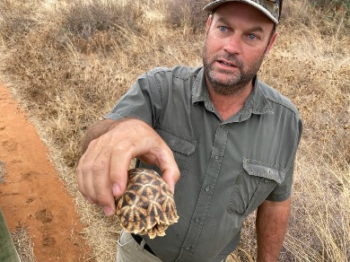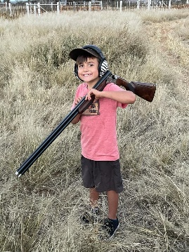

Jensens
Sören is now part of the working class in Stellenbosch, and can now be seen in many magazines as one of Nakara’s models. One of his many adventures was climbing around in Cape Town’s snow this past year.
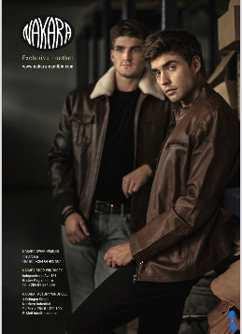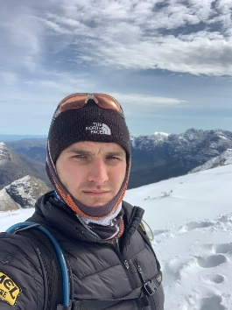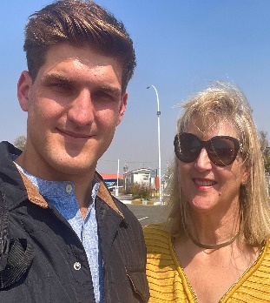
Bergran excelled this year. He got Namibian colours for cycling, was rewarded for his academic achievements and was appointed Head Boy of Windhoek Gymnasium 2022. On the down side, corruption caused Bergan’s external exams to be cancelled, as the examination papers leaked. He now has to rewrite grade 11 exams, whilst starting grade 12, which is very annoying!
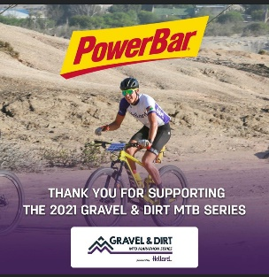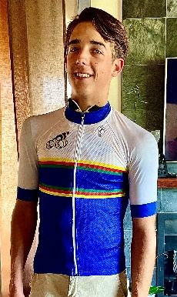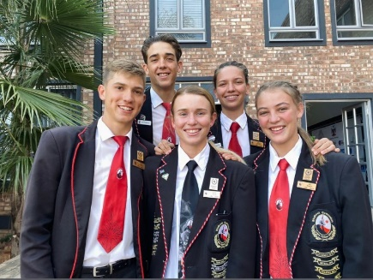
As we are starting our decent towards 2022, we hit the ground once again in the Tourism industry with the arrival of Omnicron.

In these uncertain times, the Rocky-Team would like to wish all our guests, friends and family, hope, change for the better, health and a prosperous 2022.
Let’s BELIEVE … TRUST … PRAY … and … KEEP FLYING!
Hope to see you soonest in 2022!
